Youth Winter School
- a training course
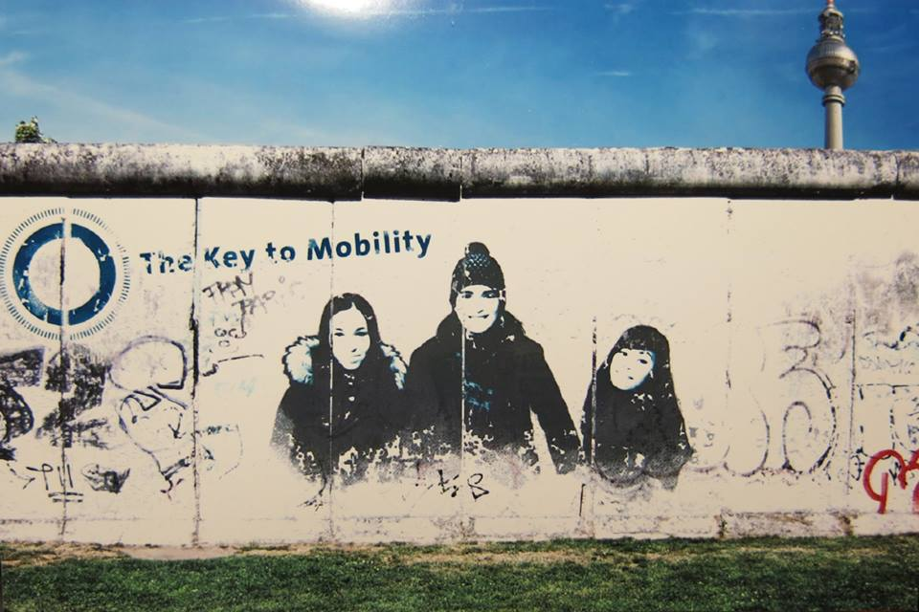

Mobility Project in the field
of Youth
21-29July 2020
Belgrade, Serbia

Dear participants,

We are glad to welcome you to the training course “Youth Winter school’’ (2019-3-SE02-KA105-002673) and arelooking forward to meet you in Belgrade very soon. Please, read all the provided informationcarefully and don’t hesitate to contact us with anything related to your participation in theproject.
About the organizer
The NGO Millennial ry has been established by young people that do their activities at national level but they take a part in different international activities as well. The aim of the association is to support interests of young people and their extracurricular activities, participate in public life and realize various projects according to the priorities of the European Union. We creates opportunities for young people who would like to be an active, try and learn something new and gain new experience and knowledge for personal and professional development. We want to enrich the educational, social and cultural life of young people living in our country, mainly young people with fewer opportunities. To accomplish its purpose, the association offer high quality non-formal education to young people, covering the three main areas of non-formal education: is socio-cultural (popular) education, education for personal development and professional training; organizing information, education, publication and training events; works with authorities, other associations, businesses and individuals; take initiatives and presentations to authorities and communities.
See you soon
Serbian Millennials in Sweden

About the project

A synonym for youth work and non-formal education represents Erasmus plus program, which has become very popular among youth organizations over the last 10-15 years. NGOs from all over Europe have the opportunity to apply for youth internationally projects and thus acquire international experiences and practices that they will later apply in their local community. Thanks to this program of the European Commission, the mobility of young people has been increased outside borders of their country. Unfortunately, a large number of these projects are thematically defined and do not deal with non-formal education for new trainers and workers. Most youth organizations apply for projects that are thematically defined, namely; youth entrepreneurship, religious diversity, youth radicalism etc. and who can't improve our capacity if we have inexperienced trainer and worker.
By returning to the basics of non-formal education, new youngest NGO are being helped to strengthen their human capacity, and older NGOs to improve their educational activities and workshop. Project – Youth Winter School, seeks to increase the capacity of new NG organizations, including itself, by developing knowledge and improving skills in the field of informal methodology and education.
We strive, after this project, for youth workers to be fully trained and prepared to initiate, develop, prepare, lead and evaluate an informal educational youth workshop in a multicultural environment.
Objectives
• To introduce participants with different learning styles and different approaches in learning;
• To develop a set of trainer skills (Communication, Facilitation, Coaching…etc) through non- formal education
• Provide participants with competences to be able to work individually or in teams as presenters, facilitators and trainers;
• To motivate and empower participants, future youth workers, to actively work with specific target group of young people (migrants, minority, refugees etc.);
• To develop participant training skills for planning and running a Workshop on the topics; Active citizenship, Human rights, Social inclusion, migrants;
• To increase capacities of youth workers to prepare and implement NFE activities where young people with different possibilities and different background will work together for better understanding among them and for stronger impact on society;
• To empower participants to work on different topics in youth work
• Create contacts with new organizations that work with diverse groups;

Activities:
The methodology is based on fundamental principles of non-formal education. Technique as work in small groups, discussions, presentation of good practices and others will allow participants to participate fully in the learning process, learning from experience and facilitating interaction and full participation in the group.
The main activity of this project is training course which will be organized in Belgrade, Serbia. As part of preparation for exchange each group has to prepare workshops which will be organized at the training in Belgrade, Serbia.
The topic will be covered during training are: methods of learning, non-formal education, how to create group and work in group, trainers role in non-formal education, how to plan training program, training tools, coaching, tolerance, anti-discrimination, hates peach movement, minorities, human right education and it role in youth work, social inclusion and practical work and creating of workshops.
Exchange of food and drink, more known as intercultural night will be part of this exchange where participants will have chance to taste different kind of food and drinks, also increase awareness and understanding of the cultural and ethnic diversity, create an atmosphere of neighborly celebration, educate about cultural differences and similarity of countries participate. You can also think of some other things to share with the group from your culture: stories, dances, songs etc. In case you play an instrument, it might be very nice to bring it. Just no power point presentation or country promotion videos, as it would be the best if you can share something in your own words! By the way, to present something from your culture does not mean it has to be something stereotypically from your country: it can be something from region, a city, your family etc.
Please note that the program does not include touristic trips and free days therefore in case you are interested in such possibilities we invite you to plan them for yourselves by arranging (on your own costs) some days before or after the training.
FOLLOW UP ACTIVITIES will be done by participants when return home. Each group has to organize local workshops for local young people. It is obligatory part of project and we expect that participants participate in it. If you do not want to participate in this phase of project or have no time, please do not come on training course. Only sharing pictures on Facebook and telling to parents and friends about project we do not consider as follow up or dissemination.
On this project we do not want to use plastic cups as we do not want to pollute our environment. Please, bring with you cup for coffee, water, tea... We will organize lottery and your cup will be delivered to another participant. And you will receive new cup. That cup will be the one you will use during the project. After the project you will bring it with you at home. It will be your gift from another participant to remind you on this project. The reason we want to use this method is that we want to avoid plastic cups. We do not want to use it as they make big impact on environment. We saw this method on project in Romania and Serbia and it worked very well. Do not forget to bring with you cup! If you forget it you have to buy it in Serbia.
ARRIVAL DAY: 21st of July before 3 PM
PROGRAMME: 22-28 July
DEPARTURE DAY: 29th around 11 AM

Partner organizations

Serbian Milenians in Sweden (Sweden)- 4 participants
European Youth Organization (Serbia)- 5 participants
Terra Slavonica (Croatia)- 4 participants
Youth Planet (Estonia)—4 participants
Modern Youth Academy Association (Turkey)- 4 participatns
Zentralrat der Serben in Deutschland e.V (Germany)- 4 participants

Target group:

Participants will be form Countries involved: Sweden, Germany, Serbia, Turkey, Croatia, Estonia
The participants ofTC – Youth Winter School will be youth workers, youth leaders, future trainers of national and international activities who are at the beginning of their youth work. Participants will firstly be selected by their sending organizations, and then by filling out the special Application forms will be confirmed by the hosting organization team according to their motivation and commitment.
Partner organizations will be in charge for having their own open calls for participants, or delegating their associates directly, and procedure of selection according to mutually agreed conditions and criteria (needs, motivation, socio-economic status, gender, etc). One common Application form for participants will be used by all the partners, and disseminated with Info pack.
Selected participants will have task-related preparation before coming to the training due to the programme’s composition.
Benefits for participants: Participants will gain a set of competences related to non formal education and how to be trainer in practice.The benefits of participants will also be seen through creativity, perseverance, resourcefulness, self-confidence, taking initiative, taking responsibility, teamwork.
Financial conditions
The youth exchange is implemented by support of the European Commission programme ERASMUS+ and the Swedish National Agency. Travel Expenses (according to Erasmus+ guidelines), accommodation, food and planned activities will be covered by the project budget.
Important notice on food:
Please, keep in mind, that the provided food may differ from the food you are used to have in your country, and, even in case of providing food for special groups, e.g. (if you are heavily meateater or vegetarian) it may not fully meet your expectations. We strongly recommend participants to inform the organizers IN ADVANCE about any special need.
Travel costs

Before buying tickets, travel plan has to be sent to organizers for approving.
After the travel plan is approved by organizer participant can buy the tickets they were approved. If participants have any change in the travel plan they have to send it again to organizer for approving. Any other option in buying tickets will be not reimbursed.
Reimbursement will be done after the final report will be approved and we receive second part of money form National Agency. We expect it will be in November 2020. Reimbursement will be in EUR and sent to sending organization account. All tickets' costs purchased in a local currency will be converted and calculated according to the exchange rate of the month given by the European Commission. Find the details here:
http://ec.europa.eu/budget/contracts_grants/info_contracts/inforeuro/inforeuro_en.cfm
The participants themselves should cover extra costs (overcoming the budget limits).
Each participant should submit the following documents for the reimbursement:
- Tickets (there must be price and name of the person stated on it) please buy tickets which can be refundable by the air company in case of a flight cancellations.
- Boarding passes (in case of loss – please get a confirmation from the airlines, that the flight was taken)
- Invoices – yes, even if you have a ticket, our accounting still needs an INVOICE.
- Online Check-in should be made before your leave Belgrade to make sure you give us boarding Passes from the way back as well.

IMPORTANT: Be aware that you can wait 5 months for reimbursement of travel costs. If you can’t wait so much, please ones more consider if it is project for you.
There is NO participation fee for this training course.
Planned travel costs for each group:
Country | Money in €
Serbia | 20
Croatia | 180
Sweden | 275
Germany | 275
Turkey | 275
Estonia | 275

During the trip to Belgrade and in return bring with you facemask and gloves
Weather
The weather in Serbia in July is warm and sunny. Bring with you comfortable and easy garments.
Visa
In case if you need visa, you can let us to send you invitation letter. However, visa costs will not be reimbursed. Please, don't forget to bring your passport or ID with you.
Insurance
We would have a first aid kit with us. But please make sure that you take any medication that you need. There are pharmacies in Belgrade, but you will be asked for recipes of doctors. There will be list of emergency doctors’ offices available for consultation when needed.
Please note that each participant is required to have travel insurance and health insurance and it is not reimbursable, as it is your choice with which company and plan suits you. Travel Insurance (For participants from EU countries the European Health Insurance Card (EHIC) is advised!
What is the European Health Insurance Card?
It is a free card that gives you access to state-provided health care during a temporary stay in any of the 28 EU countries, Iceland, Lichtenstein, Norway and Switzerland, under the same conditions and at the same cost (free in some countries) as people insured in that country.
Insurance cards are issued by your national health insurance provider: http://ec.europa.eu/social/main.jsp?catId=563&langId=en#nationalinfo
Keep in mind that it is necessary to have an additional insurance which can cover any COVID 19 related problems. Even though we expect not to have problems it is better to be safe than sorry!
ATM & Cash
In Serbia all major credit and debit cards are accepted.
Currency
Serbian currency is Serbian Dinar (RSD); if you need to change money you can do it in the airport or in any bank (1€ ≈ 118RSD)
Emergency
192 emergency number
Medication
If you take any medication please remember to bring it with you, in Serbia there are pharmacies here but if you need prescription medication you cannot buy them over the counter without a prescription. Also please, inform us of any medical conditions we need to be aware of in the registration application. If participants have any allergies especially to food this needs to be expressed in the application form above, because changes to the menu will not be possible once the project starts.
Smoking and alcohol
We do not encourage drinking and smoking, but if you want to do it, do it responsible. It is forbidden to smoke or drink inside of your rooms and activities places.
Drugs
It is completely forbidden to use drugs including “light drugs”
What to bring
- Travel Insurance (For participants from EU countries the European Health Insurance)
- Card (EHIC) is advised!
- Printed materials to represent your organization and/or projects
- PASSPORT and a copy to leave with the organizers
- Some traditional food/drinks to share during the Training Course. We don’t have possibility to use kitchen for preparation of some food, so bring something what you don’t need to prepare before using.
- In rooms there is only one socket, if you have home bring with you some plugs with more sockets.
- Bring with you cup for coffee, water, tea… We will organize lottery first day of project and your cup will be delivered to other participant, and you will receive new one. That cup you will use during the project for coffee, tea, water, all beverage you need. You will take care about that cup. After the project you will bring it with you home. You can buy or bring one from your house. But do not bring one which you love so much as it will be gifted to some other participant. At the end of project you will have good present which can remind you on this project. The reason we want you bring the cup with you is that we want to avoid use of plastic cups. We do not want to pollute our environment.
- Good Mood
Venue
Project will be held in Belgrade
Studentsko odmaralište „Radojka Lakić”
Bulevar partrijarha Germana 201
11226 Beograd
Tel: (+381 11) 3907-946

http://usob.rs/odmaralista/radojka-lakic-avala/

Accommodation will be in 2-3 bedrooms. There will be toilet in rooms. Please, bring with you, shampoos, soaps, hair dryer and everything you need for hygiene.

Taking care of cleanliness in room is your and your roommate responsibility. There will be no cleaning by the Centre employee during the stay in Centre.

How to get from the airport to the Avala?

From “Nikola Tesla” - Belgrade airport you can take mini bus A1, direction Slavija square, and you should get off at Slavija square.
Ticket price: about 300rsd (3eur) and they cannot be paid in Euros and obtained in the bus. Approximate travel time to Slavija square is 30 minutes.
Or you can take bus 72 to Zeleni venac. Ticket price 150 RSD and travels 50 minutes to Zeleni venac. In case you arrive at Zeleni Venac you will need to walk to Terazije and then catch any of the busses (22A or 31) to Slavija square. Copy this link to browser in order to see the google maps route https://shorturl.at/nR013
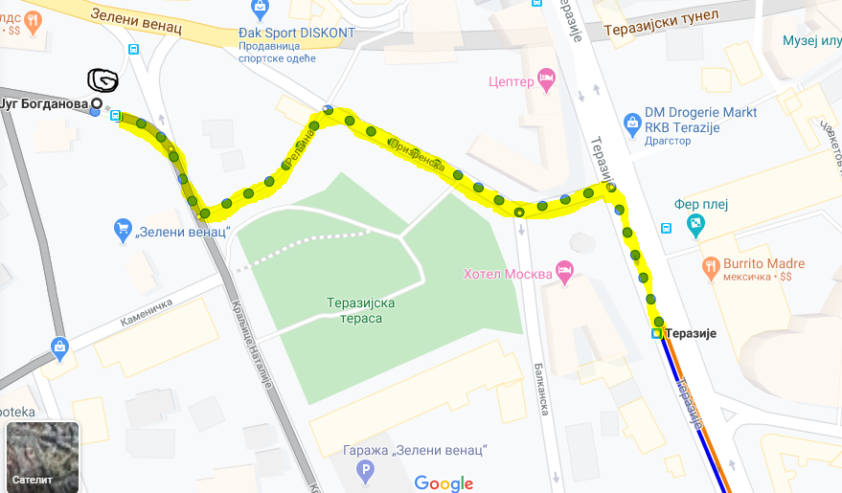
The route from last stop of bus 72 (Zeleni Venac to Terazije where you need to catch buses 22A or 31 to Slavija square)

How to reach the venue from Slavija square
Copy this link to browser in order to see the google maps route https://shorturl.at/efEV3
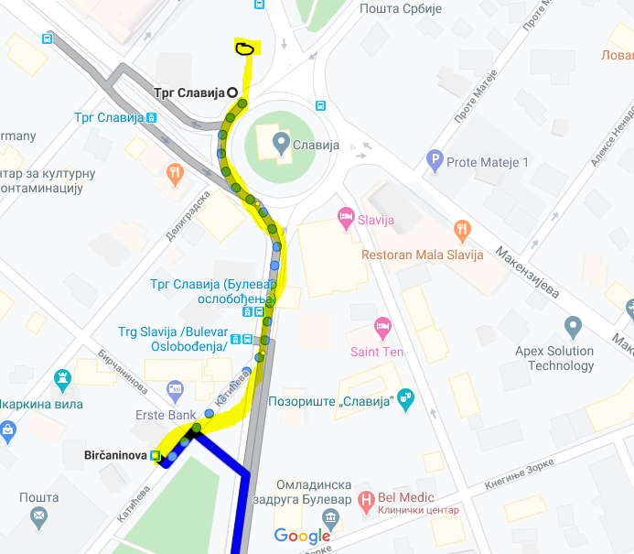 Birčaninova is the 1st station of bus 401
Walk to the bus station Slavija/Birčaninova and then enter bus 401 you need to buy the ticket at the driver and the price of it is 300 RSD
Timetable of bus 401 Slavija - Pinosava https://www.busevi.com/red-voznje/linija-401-slavija-bircaninova-pinosava/#1481838260621-4d1f132b-5084d26c-214b

You will need to exit from bus 401 at the stop Pošta approx after 37 minutes of the ride. After you arrive at Pošta station you will walk for 4-5 minutes (400m) to reach the venue.
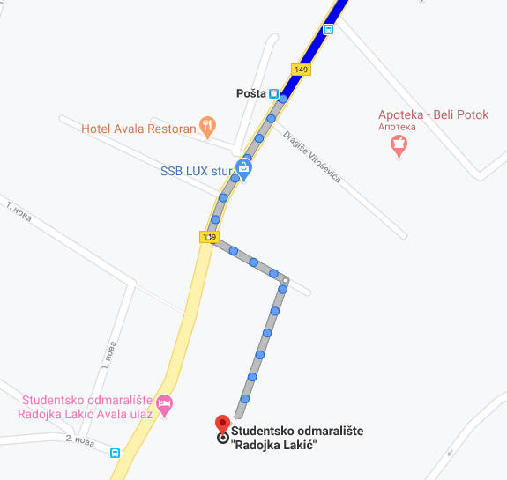

Keep in mind that it is necessary that you wear masks in the busses as it is one of the measures which is been used in Belgrade public transport in order to prevent any unwanted situation and take care of your health under COVID 19. We will provide masks, gloves and disinfection at the venue for all participants.

PLEASE NOTE: WE WILL MAKE ROOM SCHEDULES IN ADVANCE. REARRANGEMENTS ARE NOT POSSIBLE UPON ARRIVAL.
For more additional information and further questions you can contact us on:
serbian.milenials.sweden@gmail.com
SEE YOU SOON!

